Lesson Plan Title: Angles Length: 2 weeks

Note: Before you plan and write art experiences; pre-assess your students based on the proposed concepts, enduring understandings, and objectives of the unit/lesson(s). You may also gather this information from (previous) teachers, by reviewing already completed art work, consulting curriculum materials, etc., to get a better understanding of what content students already know and what they will need to know to be successful.

Pre-Assessment:
This will need to be done prior to teaching your lesson. Outline the method you will use to determine the skill/knowledge level of your students based on the concepts/enduring understandings/objectives of the lesson. (Hint: turn these into questions.) Be specific in describing what you would recognize as proficient skill/knowledge.
1. Can students choose and frame subject-matter that relates to their personal interests?
2. Can students create a print and a digital negative using basic adjustments in Adobe Photoshop CC?
3. Can students translate their digital images to the darkroom using traditional contact printing processes?
4. Can students compare their digital print with their darkroom print in terms of process and final product?
5. Can students describe the various uses for digital negatives and provide art historical examples (such as John Brewer, Nobuhiro Nakanishi, & Peter Henry Emerson)?

Concepts:
List the big ideas students will be introduced to in the lesson. These ideas are universal, timeless and transferrable. Examples of concepts used in art might include: Composition, Patterns, Technique, Rhythm, Paradox, Influence, Style, Force, Culture, Space/Time/Energy, Line, Law/Rules, Value, Expressions, Emotions, Tradition, Symbol, Movement, Shape, Improvisation, and Observation Look for concepts in the standards, content specific curriculum, etc.
- Composition
- Movement
- Observation
- Investigation
- Perspective
- Expression

Enduring Understanding (s):
Enduring Understandings show a relationship between two or more concepts; connected with an active verb. The best enduring understandings not only link two or more concepts; but demonstrate why this relationship is important. Like concepts, they are timeless, transferrable and universal. Align Standards, Prepared Graduate Competencies (PGCs) and Grade Level Expectations (GLEs) to Enduring Understandings.
- Composition determines movement.
- Observation guides investigation.
- Perspective defines expression.

Standards: (All lessons should address all standards.)
1. Observe and Learn to Comprehend
2. Envision and Critique to Reflect
3. Invent and Discover to Create
4. Relate and Connect to Transfer

Objectives/Outcomes/Learning Targets:
Objectives describe a learning experience with a condition → behavior (measurable) → criterion. Aligned to: Bloom’s – Standards – GLEs - Art learning and, when appropriate, Numeracy, Literacy and Technology. Should be written as: Objective. (Bloom’s: _____ - Standard: _____ - GLE: _____ -Art learning: _____ -Numeracy, Literacy, and/or Technology)
- After studying compositional guidelines, TSWBAT choose and frame subject-matter that relates to their personal interests. (Bloom’s: Applying – Standard: Create - GLE: Demonstrate technical proficiency and craftsmanship when planning – Art Learning: Conceptual Grounding/Ideation)
- Using an image from their first assignment, TSWBAT create a print and a digital negative using basic adjustments in Adobe Photoshop CC. (Bloom’s: Creating – Standard: Create – GLE: Demonstrate technical proficiency and craftsmanship when planning – Art Learning: Expressive Features and Characteristics)
- Using and image from their first assignment, TSWBAT translate their digital images to the darkroom using traditional contact printing processes. (Bloom’s: Understanding – Standard: Transfer – GLE: Cultural traditions and events impact visual arts within a community – Art Learning: Materials and Techniques)
- Using completed prints & a Venn Diagram, TSWBAT compare their digital print with their darkroom print in terms of process and final product. (Bloom’s: Analyzing – Standard: Reflect – GLE: Visual literacy skills help to establish personal meaning and artistic intent in works of art – Art Learning: Critical Reflection/Assessment – Literacy)
- After the digital negative SMART lecture, TSWBAT describe the various uses for digital negatives and provide art historical examples (such as John Brewer, Nobuhiro Nakanishi, & Peter Henry Emerson). (Bloom’s: Remembering – Standard: Comprehend – GLE: The history of art, world cultures, and artistic styles influence contemporary art concerns – Art Learning: Historical/Multicultural)

Differentiation:
Explain specifically how you have addressed the needs of exceptional students at both end of the skill and cognitive scale. Describe the strategies you will use for students who are already proficient and need growth beyond what you have planned for the rest of the class, as well as modifications for students with physical and/or cognitive challenges. Students must still meet the objectives.

Differentiation:  (Multiple means for students to access content and multiple modes for student to express understanding.) | Access (Resources and/or Process) | Expression (Products and/or Performance)
 | - Provide an outline of the SMART Presentation  - Provide Darkroom Guiding Handout  - Provide a list of steps for Photoshop adjustments | - Create a test strip (at one exposure) rather than a full final print
Extensions for depth and complexity: | Access (Resources and/or Process) | Expression (Products and/or Performance)
Extensions for depth and complexity: | - Allow students to experiment with adding objects to their darkroom prints (combining the photogram idea we previously explored) | - Allow students to create a cyanotype with their negative  - Allow students to tone their darkroom prints

Literacy:
List terms (vocabulary) specific to the topic that students will be introduced to in the lesson and describe how literacy is integrated into the lesson.
Vocabulary:
- Test Strip- a strip of sensitized paper used in testing; sections of which are exposed for varying lengths of time to assess its response.
- Contact Print- a photographic print made by placing a negative directly onto sensitized paper, glass, or film and illuminating it.
- Dots Per Inch – the number of dots that can be placed in a line within the span of 1 inch
Literacy Integration:
- Before, During, After questions – in three CERC paragraphs
- Venn Diagram to compare and contrast the two prints
- SMART Presentation

Materials:
Must be grade level appropriate. List everything you will need for this lesson, including art supplies and tools. (These are the materials students will use.) List all materials in a bulleted format.
- Digital Images (Jpegs)
- Printer
- Transparency Film
- Enlarger
- Darkroom Chemicals
- Black and White RC paper
- Venn Diagram Worksheet

Resources:

List all visual aids and reference material (books, slides, posters, etc. Be specific; include title, artist, etc. Make reference to where the material can be found. (These are the resources used by the teacher to support/develop the lesson.) List all resources in a bulleted format.
- Kodak Composition Presentation
- https://en.wikipedia.org/wiki/Edward_Weston#cite_note-FOOTNOTENewhall198624-69
- http://www.freestylephoto.biz/alternative-process/making-digital-negatives
- http://www.alternativephotography.com/wp/negatives/digital-negatives-gimp
- http://www.johnbrewerphotography.com/cyanotype
- http://www.leegallery.com/peter-henry-emerson/photography/
- http://nobuhironakanishi.com/gallery/layer-drawings/

Preparation:
What do you need to prepare for this experience? List steps of preparation in a bulleted format.
- Create a Digital Negative SMART Presentation
- Create a demonstration digital negative & darkroom print (save the test strip)
- Make copies of the assignment sheet and rubric
- Create a darkroom guiding handout for additional support
- Make basic Adobe Photoshop handout
- Cut matte board for mounting
- Set up Darkroom Chemicals
- Bring tubs/containers to carry test strips into the light

Safety:

Be specific about the safety procedures that need to be addressed with students. List all safety issue in a bulleted format.
- Safety glasses must be worn when working with chemicals
- Tongs must be used to move prints through the chemical process

Action to motivate/Inquiry Questions:
Describe how you will begin the lesson to stimulate student’s interest. How will you pique their curiosity and make them interested and excited about the lesson? What inquiry questions will you pose? Be specific about what you will say and do to motivate students and get them thinking and ready to participate. Be aware of the varying range of learning styles/intelligences of your students. Some ideas might include: telling a story, posing a series of questions, role-playing, etc.
Why would you adopt a hybrid process (combining traditional processes with digital processes)?
Why do artists still use traditional photographic processes when digital is available?
Why did so many artists make the switch to digital when it became readily available?
What are the advantages of alternative processes? Disadvantages?
What are the similarities and differences between your two prints?

Ideation/Inquiry:
Ideation is the creative process of generating, developing, and communicating new ideas, where an idea is understood as a basic element of thought that can be visual, concrete or abstract. List and describe inquiry questions and processes you will engage students in to help them develop ideas and plans for their artwork.
Before Questions:
- Brainstorm some subjects you could take digital photographs of
- What angles would be most interesting for those subjects?
- Does your camera have an auto or a manual focus? How do you know?
- What camera setting will you take your digital photographs at?
- Are you going to use a flash? Why or Why not?
To be answered and discussed in class before beginning their first assignment.

Instruction:
Give a detailed account (in bulleted form) of what you will teach. Be sure to include approximate time for each activity and instructional methodology: skills, lecture, inquiry, etc. Include motivation and ideation/inquiry where appropriate; including what student will understand as a result of the art experience

Day 1 | Instruction - The teacher will... (Be specific about what concepts, information, understandings, etc. will be taught.) Identify instructional methodology. KNOW (Content) and DO (Skill)  [[ After Composition Lecture (See Composition Lesson Plan) 1 1/2 before the assignment due date]]  - Introduce 1st assignment: Angles (pass out assignment sheet)  - Minimum of 24 photographs: 8 ant’s eye (low angle), 8 hip shot, 8 eye angle (higher angle). You are encouraged to shoot more but the minimum is 24. You will turn in your 3 best images digitally.  - You will print one on the color printer. Another shot will be used to make a digital negative and a darkroom print.  - Consider what sorts of subject matter makes sense to shoot at each angle. For example, pets and babies at low angle  - Consider composition guidelines while framing your images and arranging your subjects.  - Ask students to answer Before Questions in a bulleted or sentence format (to be typed into CERC paragraphs later)  - Brainstorm some subjects you could take digital photographs of.  - What angles would be most interesting for those subjects?  - Does your camera have an auto or a manual focus? How do you know?  - What camera setting will you take your digital photographs at?  - Are you going to use a flash? Why or Why not? | Learning - Students will... i.e.: explore ideation by making connections,  comparing, contrasting; synthesize possibilities for each painting technique; etc. (Be specific about what will be the intended result of the instruction as it relates to learning.) UNDERSTAND  - Students will consider the assignment parameters and possibilities for their project.  - Students will brainstorm subject matter, and consider associated angles and camera settings (including flash). | Time  (at the end of class – after Composition Lecture)  10 min
 | [[Composition Activity (See Composition Lesson Plan) ]]  Remind students to take pictures for their Angles Assignment (due next week) | - Students will observe compositional guidelines in magazines. Then create a poster with those images and accompanying explanations. | 80 min
Day 2  (1 week later) | - Greet Students & ask to answer “During and After Questions” on Angles Assignment  - Give time to answer the questions in a bulleted or full sentence format (will be typed into CERC paragraphs later)  - During:  - How did you decide what angles to use for your photographs?  - What did you chose as your subjects? Why?  - What were you thinking about as you took these photos?  - Did you do anything special or unique to achieve good digital photographs?  - Explain the process of getting the digital photographs back to school.  - After:  - After talking about the history of photography in class and taking your own pictures, why has digital photography become so popular?  - What was the easiest thing about the project? Why?  - What was the hardest thing or something you would have done differently?  - Why do you think it is important to use different angles when taking photographs?  - What do you think makes a successful digital photograph?  - Download Adobe Photoshop CC  - Search for Software Center, click the link under the search bar, copy into internet explorer or firefox (doesn’t work in chrome)  - Find Photoshop CC, download & click yes  - Return to the original Software Center window click the box to check mark it and click install selected  - Set up folders  - Under student ID folder, create “Digital Photography’  - Then, create subfolders titled the names of the assignments (check syllabus and copy from Angle Assignment down)  - Show students how to transfer images into the angle assignment folder  - Stress proper ejecting and deleting of photos (deleting from card or flash drive deletes them permanently)  - Give time for students to upload their images (don’t split into folders for each angle)  - Any additional time will be used to finish “During and After Questions” and begin typing them into CERC paragraphs. | - Students will reflect on their creative process and the images it produced  - Students will complete the downloading process to prepare themselves for the basic Photoshop demo next class.  - Students will demonstrate their abilities to make folders and properly upload their images. | 30 min  15 min  35 min
Day 3 | - Greet students and ask them to write down the inquiry question:  - Why would artists chose to use traditional processes when digital is available?  - Basic Adobe Photoshop Demo  - Pass out Basic Adobe Photoshop Handout and explain that there are several ways to do most things in Photoshop. So feel free to do the same thing your way if you have experience with the program but I’m going to show the way I do these adjustments.  - Open an image in Adobe Photoshop CC  - Right click, open with.., Adobe Photoshop CC  - Open Adobe Photoshop CC, File…, Open…, [browse folders & locate photograph]  - Basic Brightness and Contrast adjustments  - Adjustments Tab, Brightness & Contrast Icon, Sliders/Auto  - Image…, Auto Contrast  - Layer…, Adjustment Layer…, Brightness & Contrast, Sliders/Auto  - Crop Adjustments  - Left toolbar, Crop Icon, Top drop down menu (select original ratio)  - Drag borders to adjust  - Save an image  - File…, Save as…, FirstLastAA#, pull down dropdown to select jpeg  - Save in Student #, Digital Photography, Angle Assignment  - Then drag and drop (copy & paste) to public folder to turn in  - Ask students to edit at least 3 images (doesn’t have to be 1 from each angle) & turn them into the public drop folder  - Black & White  - Adjustment panel, Black & White Icon, Auto  - Save as FirstLastBW in student # folder then drag and drop to public folder to turn in  - Black & White Inverse  - (after turning black and white) Adjustment panel, Inverse Icon  - Save as FirstLastBWI in student # folder then drag and drop to public folder to turn in  - This will be our digital negative!! Show an example of one of mine.  - Show SMART presentation explaining printing & digital negatives.  - Art Vocabulary:  - Test Strip- a strip of sensitized paper used in testing; sections of which are exposed for varying lengths of time to assess its response.  - Contact Print- a photographic print made by placing a negative directly onto sensitized paper, glass, or film and illuminating it.  - Dots Per Inch – the number of dots that can be placed in a line within the span of 1 inch  - Printing: choosing printer, layout, fit to paper, and dpi  - Uses for digital negatives –  - Silver prints, cyanotypes, platinum prints, Van Dyke Brown, lumen prints, back lit transparency film.  - Use Document Camera to show the process I used to make my silver print using a digital negative (test strips then final print)  - Ask students to answer the inquiry question and share to close class | - Students will consider the advantages and disadvantages of traditional processes.  - Students will demonstrate their understanding of basic Adobe Photoshop adjustments by saving their images in the public drop folder.  - Students will take turns interacting with the SMART board to demonstrate their understanding of basic printing and darkroom use of digital negatives.  - Students will have a visual example of the darkroom process.  - Students will write about and discuss the advantages and disadvantages of traditional processes. | 10 min  40 min  20 min  5 min  5 min
Day 4 | - Greet students and ask to write down Inquiry Question  - Which print do you prefer? Why?  - Digital and Darkroom Stations (Group B then Group A)  - Take turns at the color printer with Ms. Gigliotti, Type Artist Statement & Fill out Venn Diagram (1/2 the students)  - Darkroom Demonstration with Ms. Brown (1/2 the students) – Pass out Contact Printing Guide  - 1. Make a test strip (at least 4 time intervals)  - 2. Look at strip and choose exposure time  - 3. Make another test strip (1 time interval – decided in step 2)  - 4. (Adjust exposure and test as needed)  - 5. Make a full size print  - 6. (optional) change contrast using a filter and make another test strip | - Students will compare and contrast their 2 prints.  - Students will edit to the best of their three images to print. They will demonstrate their comprehension of the printing steps through discussing them as they print.  - Students will complete a darkroom print from their digital negative to demonstrate their understanding of the contact print process. | ~40 min each rotation

Student reflective/inquiry activity:
Sample questions and activities (i.e. games, gallery walk, artist statement, interview) intended to promote deeper thinking, reflection and refined understandings precisely related to the grade level expectations. How will students reflect on their learning? A participatory activity that includes students in finding meaning, inquiring about materials and techniques and reflecting about their experience as it relates to objectives, standards and grade level expectations of the lesson.)
- Artist Statement according to Guiding Questions (Before, During, & After) typed into CERC paragraphs
- Venn Diagram to compare and contrast the two prints

Post-Assessment (teacher-centered/objectives as questions):  Have students achieved the objectives and grade level expectations specified in your lesson plan? | Post-Assessment Instrument:  How well have students achieved the objectives and grade level expectations specified in your lesson plan? Include your rubric, checklist, rating scale, etc.
1. Did students choose and frame subject-matter that relates to their personal interests?  2. Did students create a print and a digital negative using basic adjustments in Adobe Photoshop CC?  3. Did students translate their digital images to the darkroom using traditional contact printing processes?  4. Did students compare their digital print with their darkroom print in terms of process and final product?  5. Did students describe the various uses for digital negatives and provide art historical examples (such as John Brewer, Nobuhiro Nakanishi, & Peter Henry Emerson)? | Preston Visual Arts Rubric:  - Criteria for Application-  - 1 full tonal scale digital negative (inverted & in black and white)  - 1 test strip (with at least 4 stops)  - 1 color print  - 1 black and white darkroom print

Self-Reflection:
After the lesson is concluded write a brief reflection of what went well, what surprised you, and what you would do differently. Specifically address: (1) To what extent were lesson objectives achieved? (Utilize assessment data to justify your level of achievement.) (2) What changes, omissions, or additions to the lesson would you make if you were to teach again? (3)What do you envision for the next lesson? (Continued practice, reteach content, etc.)
Composition Poster (Comprehend) | Angle Application (Create) | Angle Artist Statement (Reflect) | Folder Check (Transfer)
Photo 1 Average: 3.87 | Photo 1 Average: 3.88 | Photo 1 Average: 3.71 | Photo 1 Average: 3.85
The objectives were achieved by most students. The composition poster assessed students’ understanding of the compositional guidelines, which were in turn used to frame and photograph subject-matter of their choice. This was an in-class activity where students found magazine images that correspond to the composition guidelines. Students averaged 3.87 out of 4 which means a majority of students exceeded the objective. The folder check assessed how thoughtfully students answered the inquiry questions (a daily activity). Many of these questions were about the project including various uses of digital negatives and comparing the prints. Since class-time is given for this (and resources provided for absences), most students achieved this objective as well with an average of 3.85. Additionally, almost all students (approximately 90%) created a digital negative, darkroom print, and digital print. As far as comparing the two prints, students answered an inquiry question about it but, due to time, many did not get a chance to fill out a Venn diagram. Ultimately, that objective was only partially achieved but it wasn’t due to the students’ performance.
If I were to teach this lesson again, I would make assessment clearer to the students and as a result easier on me. Part of this was due to the fact that my cooperating teacher taught the first part of the lesson and I took over the second. Because she designed the assignment, she was assessing a set of objectives that was different than the objectives I intended to assess. While I am sure students explored all of the standards, I feel the lesson would have made more sense to both me and the students if I had began with assessment and planned backwards from there. Instead, I planned my objectives around her lesson which was less successful. I would also implement the management techniques I learned while teaching the lesson. One example of this is having the students put their screens at 33 percent when they finished a step. This was a clever way to formatively assess while implementing classroom management. Another example of management techniques I would implement next time would be grouping the students to complete the project more efficiently.
For the next lesson, students will explore composition in a way they may not have considered before: by building it. Students will look at Andy Goldsworthy before creating and photographing earth art sculptures. Students will use their knowledge of compositional guidelines and angles to create interesting photographs of their natural creations. Students will continue to practice their basic Photoshop skills to make their final prints. Finally, for the upcoming lesson I would like to make the art historical component more self-guided than the last project. This will give students a chance to practice their transferrable research skills.

Appendix: Include all handouts, prompts, written materials, rubrics, etc. that will be given to student
8/9/15 Fahey
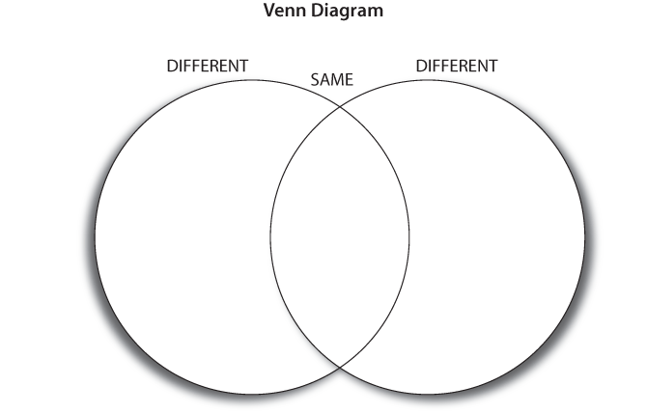

Composition Activity Instructions
  - You may work individually or in pairs to complete this activity. You have the rest of the period to create a poster that explains the guidelines of composition. Your poster must include the following guidelines with magazine pictures and explanations:
    - Definition of Composition [no pictures required] – See Composition Notes
    - Simplicity
    - Balance
    - Rule of Thirds
    - Mergers
    - Lines
    - Framing
    - Up Close
    - Bird’s Eye View
    - Ant’s Eye View
      - Feel free to take artistic liberties and cut pictures to meet the guidelines (especially helpful for Rule of Thirds & Mergers)
      - Remember to include a small explanation of why you chose the picture for each of the 9 guidelines

Printing

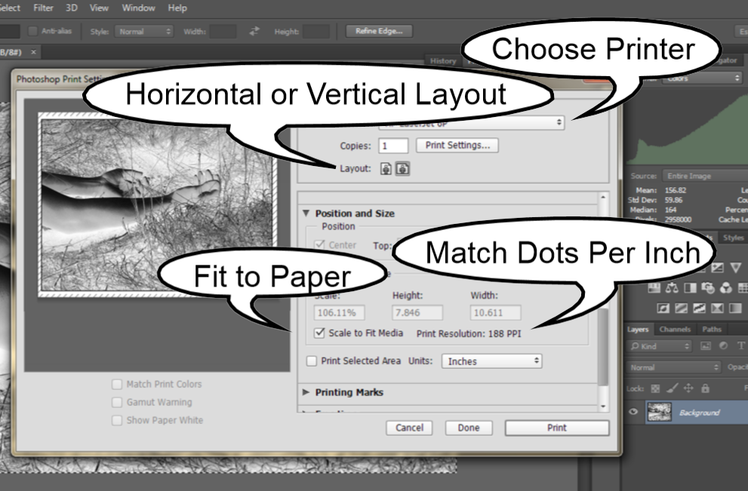

What is Dpi?
Dots per Inch (or DPI) is the number of dots that can be placed in a line within the span of 1 inch. Printers produce images by laying dots of ink on paper. Therefore, DPI is a measure of print quality and varies by printer. While a camera captures an image at a certain DPI, this information only comes into play if the photograph takes a print form. Matching an image’s DPI to that of the printer ensures a high quality print.

Changing Image Size & DPI:

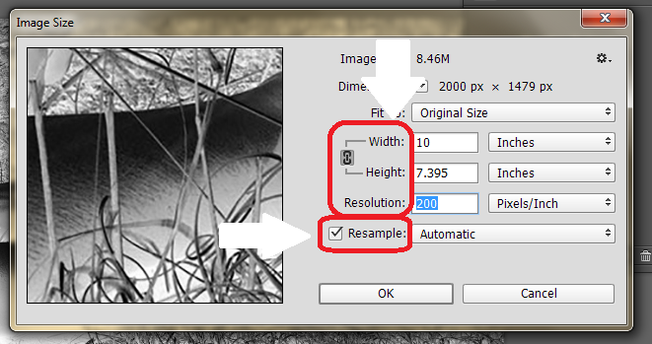
To change a picture’s DPI:
From the top bar, select Image < Image Size, then change the resolution value – make sure the resample box is checked.
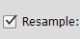

To change the image size:
From the top bar, select Image < Image Size, then adjust Height and Width (in Inches) to fit the paper size – make sure the resample box is not checked.

Basic Adobe Photoshop Adjustments
Open image

Open Adobe Photoshop CC.
Select File < Open…, then browse folders, locate, and select photograph.
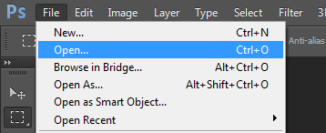

Brightness & contrast

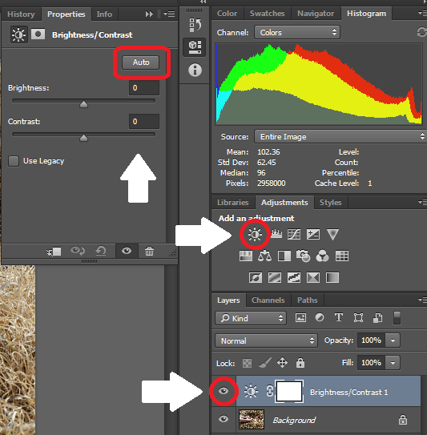

Click Adjustments Tab, select Brightness & Contrast Icon, and use sliders or “Auto” function to adjust the image. Use eye icon below to toggle visibility of your edited layer.

Cropping

On the left toolbar, select the crop icon. From the top drop down menu select original ratio. Then drag the borders to adjust. Click the checkmark in the top right to apply the crop.
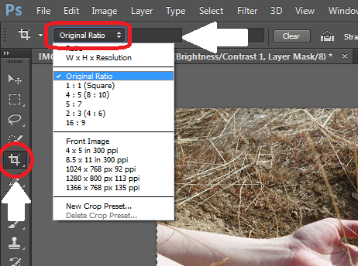

Black & white

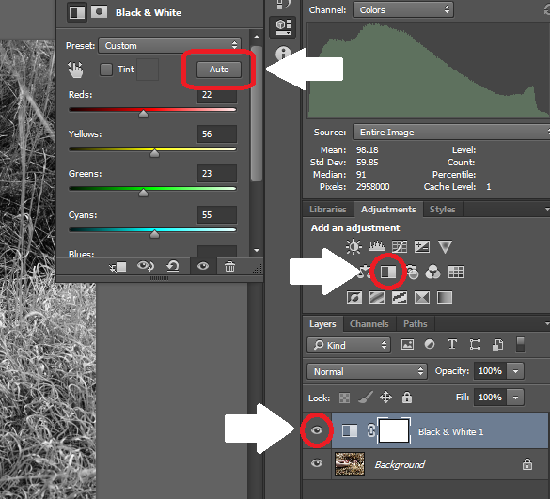

Click Adjustments Tab, select Black & White Icon, and use sliders or “Auto” function to adjust the image. Use eye icon below to toggle visibility of your edited layer.

Invert

Click Adjustments Tab, select Inverse Icon. Use eye icon below to toggle visibility of your edited layer. Note: for digital negatives, the image must be black & white and inverted.
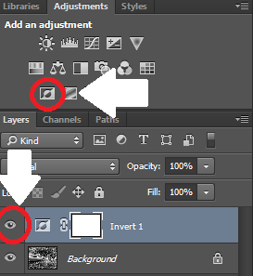

Save as
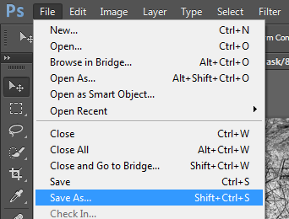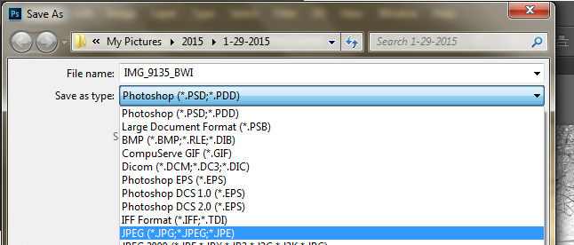
Select File < Save As…, browse and select the correct folder, rename the file appropriately, and select JPEG (*.JPG, *.JPEG, *.JPE) under the “Save as type” drop down menu.

Where do I save?
- Save Images in you Student # server!
  - Create a folder titled “Digital Photography” to store your photos
    - Create subfolders for each of the class projects
      - Angle Assignment, Annie Lebovitz, Andy Goldsworthy, Pet Poetry, Visual Gallery, etc…
        - Keep your images organized by project
- Copy and paste your edits to a flash drive & put them on a home computer or hard drive

How do I Turn my pictures in?
- Copy and paste your edits to the turn in folder (make sure they have been renamed with your first, last name, and assignment abbreviation – example: FirstLastAA1)
  - To find the correct turn in folder, open Preston Main Server < Special Projects < Photography < Fall 2015 < Purple/Teal # < Project Folder (such as Angle Assignment)

In
Digital Negatives
Darkroom
The

Vocabulary

Contact Print:
A photographic print made by placing a negative directly onto sensitized paper, glass, or film and illuminating it.
Test strip:
A strip of sensitized paper used in testing; sections of which are exposed for varying lengths of time to assess its response.

Making a contact print
1. Adjust enlarger
Turn on enlarger. Use coarse focus knob to adjust height and size of rectangle of light. Adjust aperture to 2nd to lowest light setting. Place digital negative in rectangle and turn off light.
2. Make a test strip
Find the highlights in your image (this will be the darkest part of the negative) and slide a strip of paper underneath that part of the negative. Use your folder to cover ¾ of the paper and expose for 2 seconds (count or use timer). Move folder down the paper to reveal more paper and expose for 2 more seconds. Continue until the whole strip has been exposed. Then, use the chemicals to develop the latent image.
3. Look at Test strip
After the strip has been in fixer for 3 min, use tongs to put into a tray, and carry it out into the hallway (room light). Look for the section of the paper where the highlights are exposed properly (bright but with detail). Count by 2s (starting at the lightest end) to that section to determine exposure time.
4. Make a test print
Use another strip and slide it under the same part of the negative as the last strip. Expose for the time determined in the last step. Then, use the chemicals to develop the latent image. After the strip has been in the fixer for 3 min, use tongs to put into a tray, and carry out into room light. If test print is satisfactory, use same settings to create the final print. If the test print is unsatisfactory, adjust exposure and test until it meets expectations.
5. Make a full size print
Double check that negative is within the enlarger’s light before making the final print. Turn off the enlarger and slide a whole sheet of paper underneath your negative. Expose for the same amount of time as the successful test strip and then use the chemicals to develop the latent image.
6. (Optional) use filters to adjust contrast

Darkroom Reminders

1. Tongs, tubs, & Safety glasses
Use tongs to move prints through the chemicals & drip prints over tubs before transferring them to the next chemical. Use tubs to carry unwashed prints out into room light. Safety glasses are required while using the darkroom chemicals.
2. Eye wash
An eye wash station is available for emergencies. Be careful to stay clear of the eye wash station in non-emergency situations to prevent flooding the darkroom.
3. Entering & exiting the darkroom
Remember to say “coming in” when entering the darkroom and “coming out” when exiting to avoid collisions. This will be especially important when making and viewing test strips.
4. Coarse focus knob
Use the coarse focus knob to adjust the height of the light housing (and the size of the rectangle of light). Do not adjust height by handling the housing.
5. Negative carrier
Do not remove or adjust negative carrier without using the lever to lift the housing first.
6. Light Housing
Do not open the light housing while the enlarger light is on as it will flood the darkroom with light.
7. Phones
Cell phones and other electronic devices with illuminated screens are not allowed in the darkroom as they may accidently expose the photo paper to unsafe light.
8. When prints are washing
Step back from sink while print is washing to allow other students to access the chemicals.

